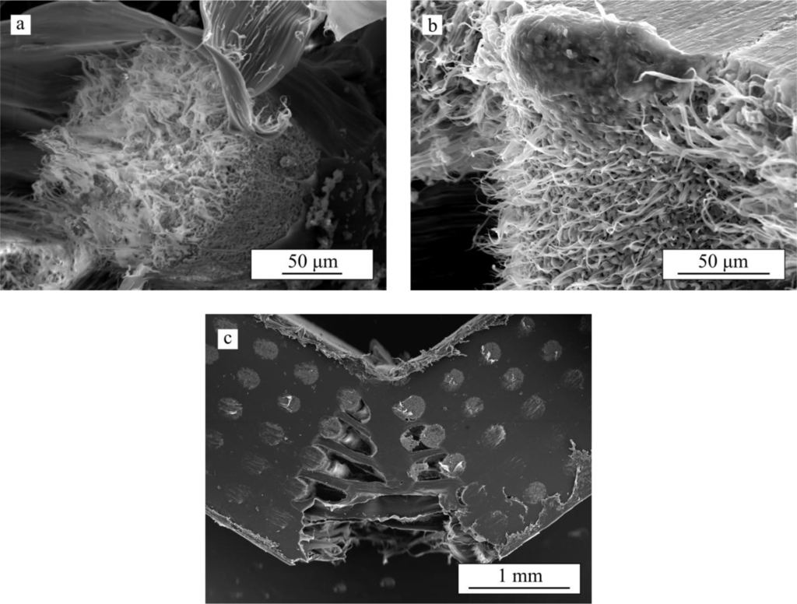

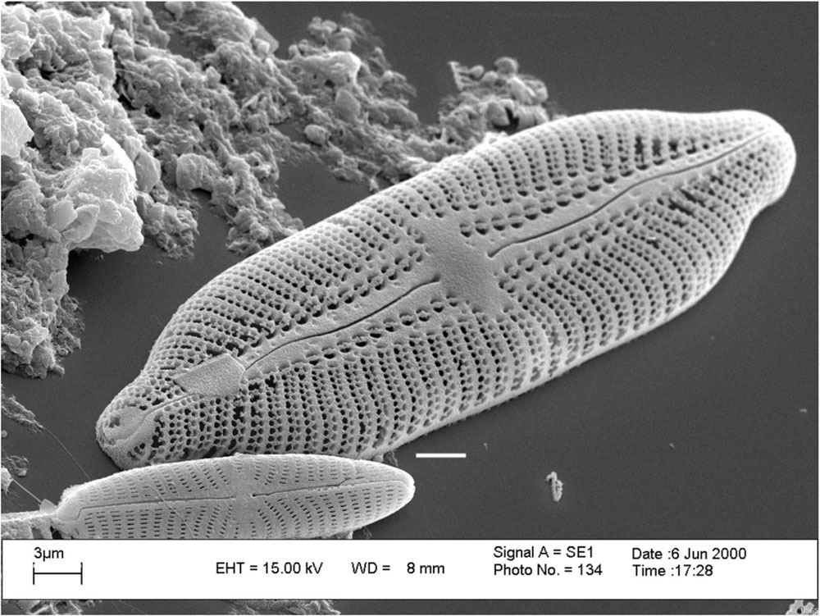
d
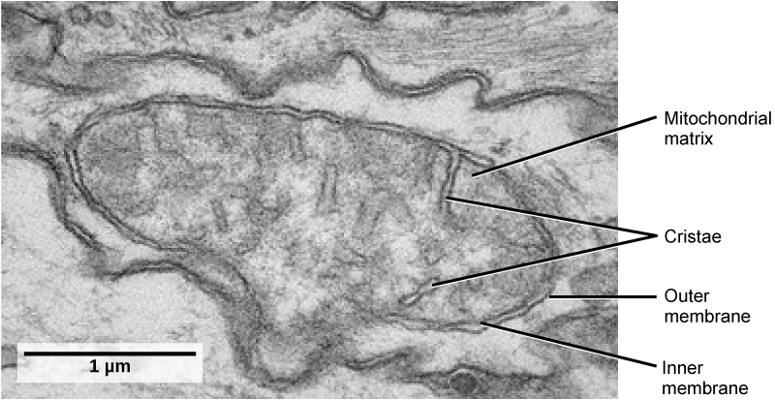
e

For each of the specimens above:
- Calculate magnification of the image using the scale bar. Follow and label steps a, b, and c. Box in answer.

- Calculate size of the specimen using the scale bar. Follow steps 1 – 4 and box in answer. Make sure to have units labeled.

Example:
Image a
- Length of scale bar –
- Convert to same unit as scale bar –
- Divide image scale bar length by actual object length (b / a) -
Answer =

- Length of specimen in mm –
- Length of scale bar in mm –
- Divide length of specimen by length of scale bar –
- Multiply scale bar label by the last answer =

