Can read more about these ideas here: http://seniorbiology.com/eei.html -
- What is the effect of temperature (the manipulated or independent variable, IV) on the enzyme digestion of starch (the dependent variable, DV).
For example, do young leaves have the same density and distribution of stomata as older leaves; or how does temperature (IV) in a natural environment affect stoma opening (DV)? In this second case you do not need you to control the environmental temperature, but you do need to measure the DV at different temperatures.
One way to address the confounding variables (eg humidity) is to collect data on the other variable as well. That is, call the stoma/temperature data Part I, and call the stoma/humidity data Part II. You can run the statistics on each pair separately, but, for students who are not that "stats-savvy" then they could look for interactions between them at a visual level.
- Do probiotics survive the digestive tract as claimed?
- Factors affecting enzyme function
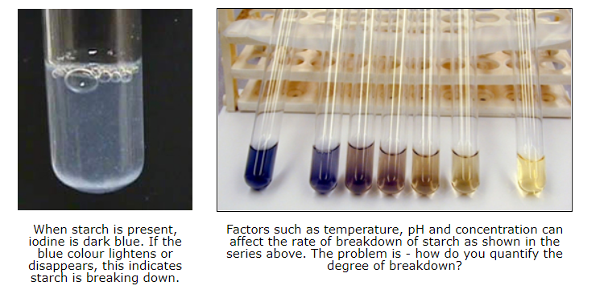
- Lipase
Lipase can break down the fat in milk into fatty acids. This can be observed by first making the milk alkaline by the addition of a weak solution of sodium bicarbonate. If the indicator phenolphthalein is present, the progress of the reaction can be observed.

Working concentrations suggested by the supplier:

2 mL milk (fresh or UHT, full cream, homogenized)
7 drops 0.5 M sodium carbonate
5 drops phenolphthalein (1%)
1 mL lipase (5%)
- Catalase: present in potatoes, apples, liver etc

- Lactase / Lactose
A good EEI might be to investigate the factors influencing the rate of formation of lactic acid upon the addition of some starter bacteria (eg plain yoghurt). I won't say what they are but a couple of the following are suspects: heat, amount of bacteria added, light, access to air, shape of container, sugar concentration, initial pH, amount of fat (normal, low fat, skim), degree of agitation, and so on.

- Seedling ideas:
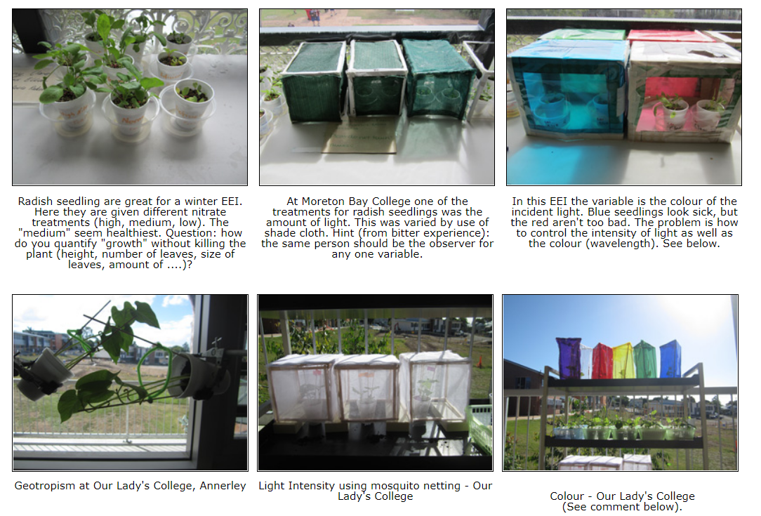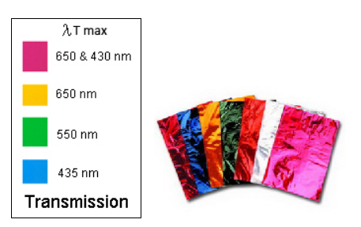
- CASE 1: In this leaf growth experiment you may, for example, choose to have the "amount of fertilizer" as the independent (manipulated) variable, and "leaf surface area" as a measure of growth for the dependent variable. If these are measured just once, say after 3 weeks, then "time" is a controlled variable (along with water, sunlight, temperature etc). You could prepare a graph where you plot surface area (y-axis) and concentration (x-axis) and there will be one line.
- CASE 2: However, "time" can be an independent variable as well. You use the "amount of fertilizer" as the independent variable but if you measure the dependent variable (surface area) every week at 0, 1, 2, 3, and 4 weeks then you really have two experiments in one. There are two independent variables: "time" and "amount of fertilizer" but they can be examined separately. A plot of surface area (y-axis) vs time (x-axis) would show 3 lines (if you used 3 different concentrations of fertilizer). This would be most valuable as it would show you growth rate at each concentration. You could prepare another graph where you plot surface area (y-axis) and concentration (x-axis) to get 5 lines (one for each weekly measurement including the starting height at t=0). This would be harder for you to visualise and interpret however.

- The effect of different concentrations of hormones on the growth of tissue cultured plants
- Effect of temperature and chemicals on a beetroot membrane
- Salt damage on a beetroot membrane: effect on osmosis
- Effect of surface area on a beetroot membrane osmosis

- Banana ripening kinetics
It seems that the hormone ethylene triggers the production of enzymes. For example, the α(1→4) bonds of starch may be hydrolyzed by amylases (and glucosidases) or broken by starch phosphorylases. It has been observed that sucrose starts to accumulate first, before glucose and fructose, and parallel to starch disappearance. See N. Terra et al, 1983. "Starch-Sugar Transformation during banana ripening". Journal of Food Science, V48(4) p1097-1100.
This suggests a great EEI. The question can be asked "What conditions affect the kinetics of banana ripening?" The obvious one is temperature, but an intriguing one is the presence of ethylene (ethene). This gas is produced as bananas begin to ripen so it would be instructive to compare bananas ripening in a plastic bag where the ethylene is trapped in with the fruit, versus ripening in a breeze where the ethylene is blown away. I've used a little fan out of a computer. That's all you need.
What would you measure as an index of ripening? Some books suggest iodine but that may be too inaccurate for a Biology EEI. I suggest measuring the concentration of glucose. There are a couple of methods of measuring this but the two main ones would have to be: (a) using glucose test strips either by comparison against colour standards, or by use of a glucometer as used in diabetes monitoring; (b) if you also do Chemistry then a titration could be the way to go - using either using Benedict's solution.
- Allopathy in the germination of seeds
Allelopathy is a biological phenomenon by which an organism produces one or more biochemicals that influence the growth, survival, and reproduction of other organisms. These biochemicals are known as allelochemicals and can have beneficial (positive allelopathy) or detrimental (negative allelopathy) effects on the target organisms. The possible application of allelopathy in agriculture is the subject of much research. Current research is focused on the effects of weeds on crops, crops on weeds, and crops on crops. This research furthers the possibility of using allelochemicals as growth regulators and natural herbicides, to promote sustainable agriculture.
One student, Melissa, said: "We did and experiment in class to see the effect living plants may have on other plants that may be present nearby. This is known as allelopathy. Secondary metabolites cause these allelopathic effects.The most commonly known plant to exhibit this is the black walnut tree. Where a black walnut tree is present, most other plants cannot grow.Walnut trees produce a compund called Juglone, which stops other plants growing. In this experiment we tested the allelopathic effects of walnuts, oranges and lemons on lettuce seeds (Lactuca sativa). The aim of the experiment is to establish if the listed plants inhibit the germination of lettuce seeds and if they effect seedling growth."
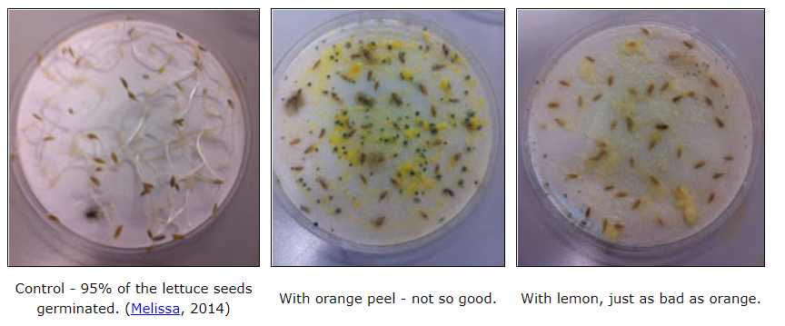
- Ethanol biofuel from green algae
Ethanol is used as an alternative fuel source and as a petrol additive. It burns cleaner than petrol and diesel and can be produced from (renewable) algae by fermentation rather than being extracted from non-renewable sources such as oil. Algae grow very simply, needing only water, sunlight and carbon dioxide to thrive. After the algae is harvested and treated to release carbohydrates, yeast is added to begin fermentation, which creates ethanol in a similar way that ethanol is produced in wine or beer. One of the major benefits of using algae to produce ethanol is that algae can be harvested day after day, unlike competing sources, such as corn and soybeans.
Algae can also nearly double in quantity overnight, if the conditions are perfect (see EEI suggestion below). To achieve perfect growing conditions, producers must ensure that algae do not get too much direct sunlight, which can kill them, and that the growing environment is moist, has a constant warm temperature and has clean water with balanced salinity and the optimum pH. A good (but difficult) EEI would to make ethanol by the fermentation of algae as it can be done at home or in the lab.
There are many variables to consider in maximizing the amount of ethanol produced: type of algae, conditions (temp, sunlight, pH, water salinity), time before harvest (= money), type of yeast and added nutrients. How do you measure the amount of ethanol produced by distillation (density, volume, mass)? Choose one or two (at the most) variables to manipulate and control the rest. Plenty of websites available (note: biodiesel fuel from algal oil is a different process and probably too hard for senior biology). Students may find that a lot of time has to be spent understanding algae fermentation and this may make this EEI too time-consuming. Nevertheless a Australian Government report on these variables can be downloaded here: Biohydrocarbons from Algae.
- Microalgae
Biology teacher Ivy Walsham has suggested independent variables worth considering for an EEI using microalgae: Test amount of light, intensity, different nutrients, etc..
She says "Culture the microalgae in test tubes and record the daily growth. You can use a haemocytometer for counting the microalgae. If you culture under ideal conditions for 10 days you will get a graph similar to bacterial growth (exponential graph).
You can maintain the algae for a long time in the laboratory by sub-culturing it in agar plates."

- Bulbs that pull themselves down into the soil
This suggests a possible EEI. Are you going to use bulbs of one particular size or compare burial rate/final depth of bulbs of different size classes? How does the final burial depth and switch over from vertical to horizontal contractile roots compare with depth of bulbs in the field?
- Seed germination
For an interesting IA you could investigate the conditions needed for germination of several related species, particularly those with horticultural value. Hint: select species for which you can obtain large number of seeds so that you can have a good experimental design. Try and find out when the seeds germinate in the field as this might help you determine the most likely treatments to use. Avoid using orchids as they may have very special requirements like a suitable fungus being present.
Factors to investigate include: hard seed coats (common in legumes); an impermeable seed coat (prevents water uptake); germination inhibitor (causing dormancy) - some seeds contain substances that prevent germination and these inhibitors are leached out over a period of time (maybe years); temperature requirement (many seeds will germinate only at a particular temperature); light requirement (some seeds require light to germinate (often fairly small ones) or just the opposite - they won't grow except in the dark. Think carefully about how many factors you can test with the number of seeds you have in hand.
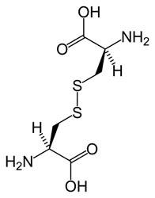
Cystine is composed of two cysteines linked by a disulfide bond (shown here in its neutral form).
- The Effect of pH on the Strength of Keratin (hair protein).
Keratin is a protein that contains a high concentration of the amino acid cysteine; this contains a sulphur atom. The sulfur atoms from two cystines join together, forming a very strong disulfide bond (see below). These bonds are covalent and form strong links making the tertiary structure of the protein very stable. The disulfide bonds occur down the length of the keratin fibre and the cross-linking between the keratin chains account for the strength of hair.
Within each hair strand the keratin chains are also linked with hydrogen bonds between the oxygen atoms on the CO groups and the H atoms on either the OH or NH groups. Although they are individually weaker than disulfide bonds, hydrogen bonds are in much higher proportions to the disulphide bonds making them important in maintaining the tertiary structure of the protein. A good investigation would be to test the strength of hair as a function of pH. Try putting the hair in solutions of varying pH values from 1 to 14 (for say 10 minutes as an initial trial).

- Determine the concentration of bacteria in various situations, e.g. milk at different ages, water from local creek.
- How does the shell of a snail grow in size and shape as a snail becomes larger?
- The Effects of Exercise on the Maintenance of Homeostasis
- Does an individual's ability to return to their normal physiological state, after a period of exercise, depend on individual differences?
Homeostasis is the maintenance of a relatively stable internal environment. However, exercise disrupts homeostasis. The changes that occur in response to exercise are the body's attempt to reduce the stress that has been placed on the entire organism. Changes that are normal during exercise would be considered abnormal if they were occurring in a non-exercising individual. For example, the level to which the body temperature rises during exercise would be considered a fever if the person were not exercising. Exercise physiology is the study of both the functional changes that occur in response to a single bout of exercise and the adaptations that occur as a result of regular, repeated bouts of exercise.

- Sensation of smell and taste
It is often said that heavy smokers can't taste and smell things as well as non-smokers. Can you conduct experiments to show if this is so? Can you relate your findings to the length of time the people have been smoking and/or the number of cigarettes they have each day?
Easiest substances to use are ones that you can measure and dilute accurately so you can find out what is the lowest concentration of a substance your tester can smell or taste (a few suggestions - vinegar, honey, sesame seed oil, chilli sauce etc - don't use anything poisonous or substances that will evaporate very fast). Many of the things we think we taste, we really smell, and there are only four basic taste sensations, sweet, acid, salty and bitter.
- The rate of fall of, and distance traveled by, winged seeds in relation to their structure.
- Testing for salt tolerance or lead tolerance in races of grasses
- Inter-specific interaction between clover and grass; addition of fertilizer.
- Observe the stages of mitosis in actively-dividing plant meristem tissue.
- Observing patterns in the distribution of a simple plant
Use a quadrat to estimate the population density of a simple plant that grows on the bark of trees. Relate its distribution to environmental factors.

